

**SHAID SMARAK COLLEGE**

Kirtipur, Kathmandu

*Lab Sheet of Computer Fundamentals*

**Submitted by :-**

1st semester

Shrijal Maharjan

**Submitted to :-**

Kijush Maharjan

LAB 2

Command Line Interface(CLI)

A command line interface (CLI) processes commands to a computer program in the form of lines or text. The program which handles the interface is called a command line processor. Opereating systems implement a CLI in a shell for interactive access to operating system functions or services. Such access was primarily provided to users by computer terminals.

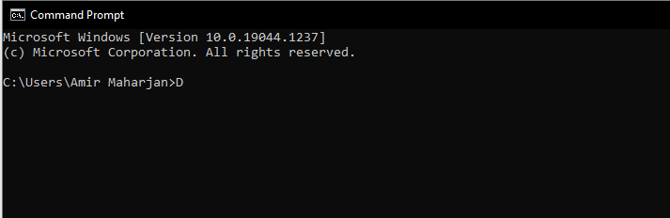

Some commands of CLI are as follows:

# DIR